19. Install a C compiler in the virtual machine created using virtual box / VM Ware Workstation / Player and execute Simple C Programs.
AIM:
To install the GCC C compiler in the Ubuntu virtual machine created using Oracle VM VirtualBox and execute simple C programs.

PROCEDURE
- Start the Ubuntu virtual machine in Oracle VM VirtualBox.
- Open the Terminal using Ctrl + Alt + T.
- Update the package list using:
Bash
sudo apt update Install the GCC compiler:
Bash
sudo apt install gcc -y Verify the installation:
Bash
gcc --version Create a C source file:
Bash
nano hello.c Enter a simple C program to display Hello World.
- Save the program using Ctrl + O, press Enter, and exit using Ctrl + X.
- Compile the C program:
Bash
gcc hello.c -o hello Execute the compiled program:
Bash
./hello Verify that the expected output is displayed in the terminal.

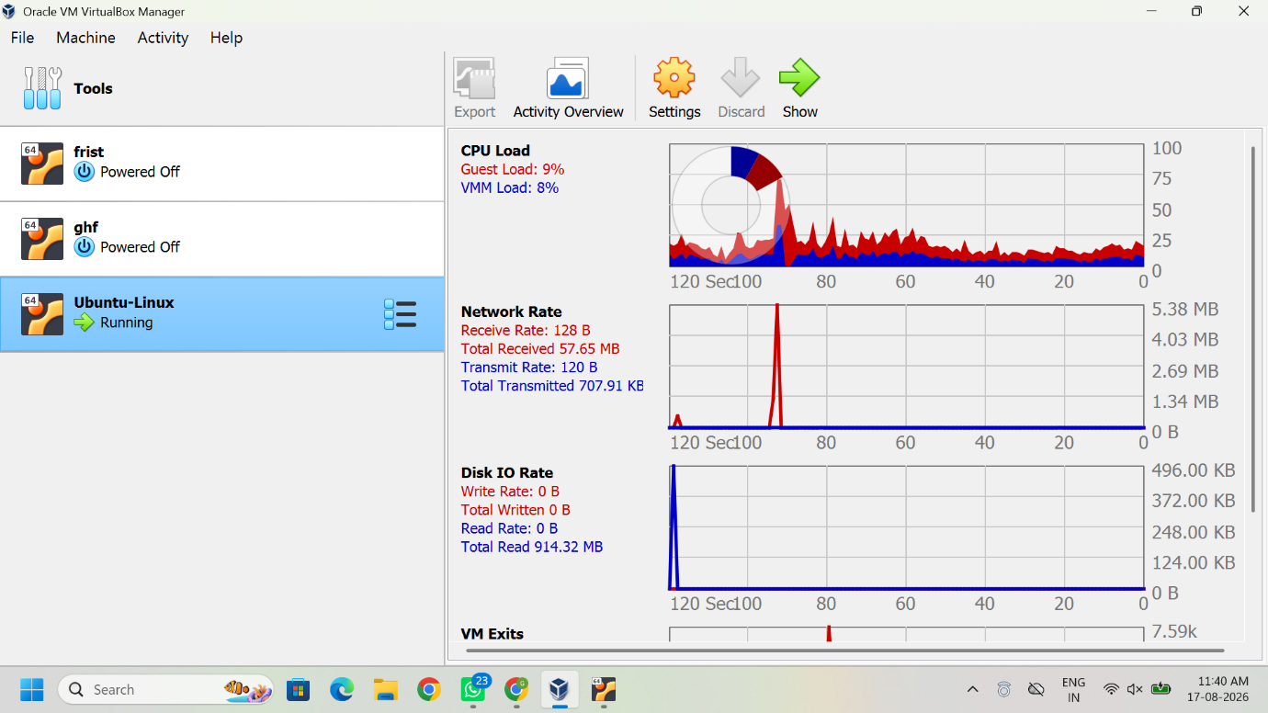
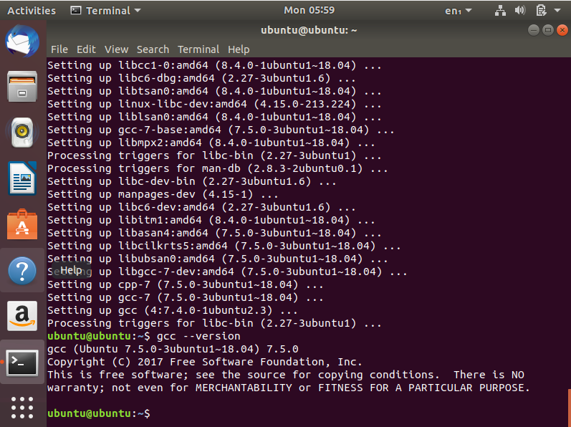

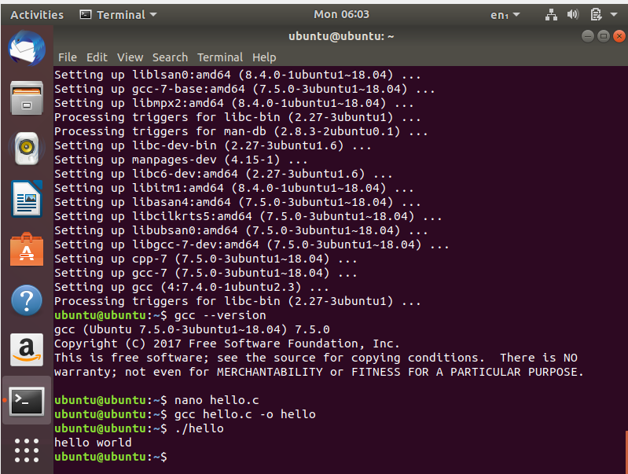

RESULT
The GCC C compiler was successfully installed in the Ubuntu virtual machine, and the simple C program was successfully compiled and executed.

